THE BENEFITS OF A CONSISTENT AND RELIABLE

QUOTING PROCESS

June 09, 2017

The standard request for quotation (RFQ) process is one of the most common practices carried out by any purchasing manager; however, it is a process that often results in extensive turnaround times due to detailed pricing information and other selection criteria.
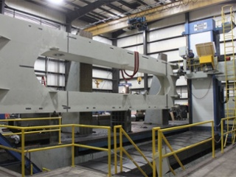

With services and goods constantly evolving, it is critical for any organization to prepare and provide a qualified and competitive bid - The metal fabrication process is no exception. At ExacTech Inc., all incoming quotes are reviewed for material, weld, machining, paint, and any secondary requirements such as stress relieving. This assures a consistent, reliable bid day in and day out and an opportunity to gain business while earning the customers’ trust in the process.
Below is an effective step-by-step quoting process that will help assure a consistent and reliable quoting process:

7-Step Quoting Process
- To begin the process, all incoming quotes are reviewed for material, welding, machining, paint, and any other secondary requirements that are necessary for the product.
- All quotes are entered into a “quote log,” which contains a due date in which we will provide the customer a precise quote.
- The material needed for each product is then reviewed for availability. Various departments assess what will be needed and how quickly they can receive the required supplies. By carrying out this process, ExacTech can ensure that all necessary materials will be available from the beginning stages to the final product.
- We review the customer’s due date once again in order to ensure that the due date can be met after consideration.
- ExacTech provides a quote for machining hours, tooling and material requirements, outside services, and the allotted fabrication hours.
- The quote is then assembled and reviewed for accuracy prior to submitting to our customers. At ExacTech we review every fabrication process multiple times before sending a final quote to ensure our estimate is as precise as it possibly could be!
- The quote is submitted to the customer for review and consideration. ExacTech will initiate a follow-up call for any questions or concerns the customer may have regarding the estimate.
At ExacTech, we take great pride in meeting and exceeding our customer’s strictest quality and delivery requirements. Follow this 7-step process to see how ExacTech is the perfect fit for all your turnkey solutions.

